ERS DAY4
1. count word frequencies in a paragraph using fixed size array of unique words
#include <stdio.h>
#include <string.h>

int main() {
char str[200];
char words[50][20];
int count[50] = {0};
int n = 0;

printf("Enter a paragraph:\n");
fgets(str, sizeof(str), stdin);

str[strcspn(str, "\n")] = '\0';

char *token = strtok(str, " ");

while(token != NULL) {
int found = 0;

for(int i = 0; i < n; i++) {
if(strcmp(words[i], token) == 0) {
count[i]++;
found = 1;
break;
}
}

if(found == 0) {
strcpy(words[n], token);
count[n] = 1;
n++;
}

token = strtok(NULL, " ");
}

printf("\nWord Frequencies:\n");
for(int i = 0; i < n; i++) {
printf("%s : %d\n", words[i], count[i]);
}

return 0;
}
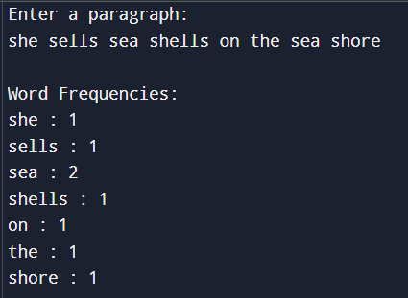

2.create array of char* to store name of cities entered by the user .implement functions ton sort them alphabetically and free allocated memory

#include <stdio.h>
#include <stdlib.h>
#include <string.h>

int main() {
int n;
char *cities[20];
char temp[50];
char *swap;

printf("Enter number of cities: ");
scanf("%d", &n);
getchar();

for(int i = 0; i < n; i++) {
printf("Enter city %d: ", i+1);
fgets(temp, sizeof(temp), stdin);
temp[strcspn(temp, "\n")] = '\0';

cities[i] = (char*)malloc(strlen(temp)+1);
strcpy(cities[i], temp);
}
for(int i = 0; i < n-1; i++) {
for(int j = i+1; j < n; j++) {
if(strcmp(cities[i], cities[j]) > 0) {
swap = cities[i];
cities[i] = cities[j];
cities[j] = swap;
}
}
}

printf("\nSorted Cities:\n");
for(int i = 0; i < n; i++) {
printf("%s\n", cities[i]);
}

for(int i = 0; i < n; i++) {
free(cities[i]);
}

return 0;
}
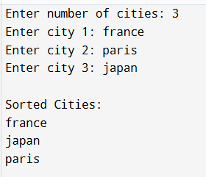

3.swap double pointer
#include <stdio.h>
#include <stdlib.h>
#include <string.h>

void swap(char **a, char **b) {
char *temp = *a;
*a = *b;
*b = temp;
}

int main() {
char *str1, *str2;

str1 = (char*)malloc(20);
str2 = (char*)malloc(20);

strcpy(str1, "Apple");
strcpy(str2, "Mango");

printf("Before swap:str1 = %s str2 = %s\n", str1, str2);

swap(&str1, &str2);
printf("After swapnstr1 = %s str2 = %s", str1, str2);

free(str1);
free(str2);

return 0;
}
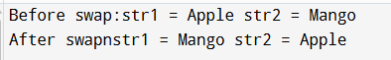

4.unique elements in row and column
#include <stdio.h>
#include <stdbool.h>

#define N 9

bool checkRows(int arr[N][N]) {
for (int i = 0; i < N; i++) {
int freq[10] = {0};
for (int j = 0; j < N; j++) {
int val = arr[i][j];
if (val < 1 || val > 9 || freq[val] == 1)
return false;
freq[val] = 1;
}
}
return true;
}

bool checkCols(int arr[N][N]) {
for (int j = 0; j < N; j++) {
int freq[10] = {0};
for (int i = 0; i < N; i++) {
int val = arr[i][j];
if (val < 1 || val > 9 || freq[val] == 1)
return false;
freq[val] = 1;
}
}
return true;
}

int main() {
int grid[N][N];

for (int i = 0; i < N; i++)
for (int j = 0; j < N; j++)
scanf("%d", &grid[i][j]);

if (checkRows(grid) && checkCols(grid))
printf("All rows and columns are unique\n");
else
printf("Invalid.\n");

return 0;
}

5.structure implementation
#include <stdio.h>

struct Student {
int roll;
char name[50];
int marks;
};

int main() {
struct Student students[5];
int i, maxMarks = -1;

for(i = 0; i < 5; i++) {
printf("student %d: ",i+1);
printf("roll number:");
scanf("%d", &students[i].roll);

printf("Enter name: ");
scanf("%s", students[i].name);
printf("mark:");
scanf("%d", &students[i].marks);

if(students[i].marks > maxMarks)
maxMarks = students[i].marks;
}

printf("\nTopper(s) Details:\n");
for(i = 0; i < 5; i++) {
if(students[i].marks == maxMarks) {
printf("Roll No: %d, Name: %s, Marks: %d\n",
students[i].roll, students[i].name, students[i].marks);
}
}

return 0;
}
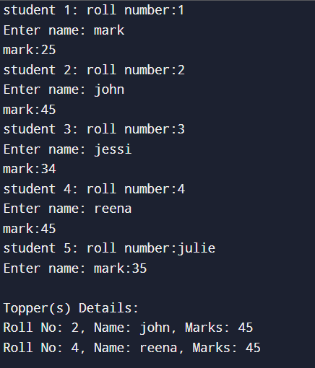

6.struct for employees
#include <stdio.h>

struct Employee {
int id;
char name[50];
double salary;
};

int main() {
struct Employee emp[10];
double total = 0, max = -1;
int i;
for(i = 0; i < 5; i++) {
printf("employee %d: ", i+1);
printf("Enter ID :");
scanf("%d", &emp[i].id);

printf("Enter name:");
scanf("%s", emp[i].name);

printf("Enter salary:");
scanf("%lf", &emp[i].salary);

total += emp[i].salary;
if(emp[i].salary > max)
max = emp[i].salary;
}

printf("\nTotal Salary Payout: %.2lf\n", total);

printf("\nEmployee(s) with Highest Salary:\n");
for(i = 0; i < 10; i++) {
if(emp[i].salary == max)
printf("ID: %d, Name: %s, Salary: %.2lf\n",
emp[i].id, emp[i].name, emp[i].salary);
}

return 0;
}
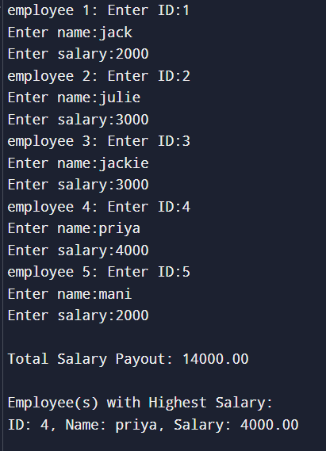
7. use a pointer to struct student to update marks,print updated details demonstrate by passing by pointer is efficient passing by value

#include <stdio.h>
#include <string.h>

struct Student {
int roll;
char name[50];
int marks;
};

void updateMarks(struct Student *s, int newMarks) {
s->marks = newMarks;
}

void printStudent(struct Student s) {
printf("Roll No: %d, Name: %s, Marks: %d\n", s.roll, s.name, s.marks);
}

int main() {
struct Student st;

printf("Enter roll number: ");
scanf("%d", &st.roll);
printf("Enter name: ");
scanf("%s", st.name);
printf("Enter marks: ");
scanf("%d", &st.marks);

printf("\nBefore update:\n");
printStudent(st);

updateMarks(&st, 95);

printf("\nAfter update:\n");
printStudent(st);

return 0;
}
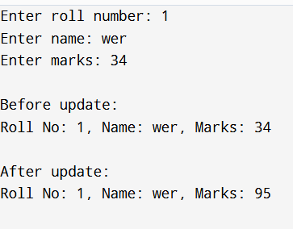
8. alocate memory dynamically for struct item array based on user input size implement add and delete operations safely

#include <stdio.h>
#include <stdlib.h>
#include <string.h>

struct Item {
int id;
char name[50];
};

struct Item* addItem(struct Item* items, int *size) {
(*size)++;
items = (struct Item*)realloc(items, (*size) * sizeof(struct Item));
if(items == NULL) {
printf("Memory allocation failed!\n");
exit(1);
}

printf("Enter ID : ");
scanf("%d", &items[*size - 1].id);
printf("Enter name : ");
scanf("%s", items[*size - 1].name);

return items;
}

struct Item* deleteItem(struct Item* items, int *size, int index) {
if(index < 0 || index >= *size) {
printf("Invalid index!\n");
return items;
}

for(int i = index; i < (*size) - 1; i++) {
items[i] = items[i + 1];
}

(*size)--;
items = (struct Item*)realloc(items, (*size) * sizeof(struct Item));
if(*size > 0 && items == NULL) {
printf("Memory allocation failed!\n");
exit(1);
}

return items;
}

void printItems(struct Item* items, int size) {
printf("\nItems List:\n");
for(int i = 0; i < size; i++) {
printf("%d: ID=%d, Name=%s\n", i, items[i].id, items[i].name);
}
}

int main() {
int n;
printf("Enter: ");
scanf("%d", &n);

struct Item* items = (struct Item*)malloc(n * sizeof(struct Item));
if(items == NULL) {
printf("failed!\n");
return 1;
}

for(int i = 0; i < n; i++) {
printf("Enter ID %d: ", i);
scanf("%d", &items[i].id);
printf("Enter name %d: ", i);
scanf("%s", items[i].name);
}

printItems(items, n);

items = addItem(items, &n);
printf("\nAfter adding :");
printItems(items, n);
int s;
printf("enter index");
scanf("%d",&s);

items = deleteItem(items, &s,1);
printf("\nAfter deleting :");
printItems(items, n);

free(items);
return 0;
}
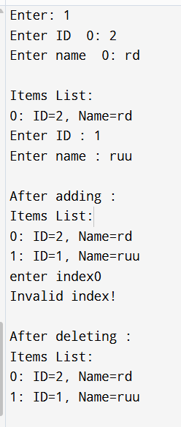
9. define a struct product with price, discount, one that calculate discount and price(call by value) another that updates the price in original structure (call by address)

#include <stdio.h>

struct Product {
double price;
double discount;
};

double calcDiscount(struct Product p) {
return p.price - (p.price * p.discount / 100);
}

void updatePrice(struct Product *p) {
p->price = p->price - (p->price * p->discount / 100);
}

int main() {
struct Product prod;

printf("Enter price: ");
scanf("%lf", &prod.price);
printf("Enter discount : ");
scanf("%lf", &prod.discount);

printf("Discounted price (call by value): %.2lf\n", calcDiscount(prod));
printf("Original price after call by value: %.2lf\n", prod.price);

updatePrice(&prod);
printf("Price after call by address: %.2lf\n", prod.price);

return 0;
}

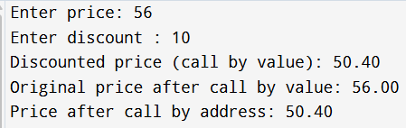
10. use typedef are using to create alias for a structure and demonstrate usage
#include <stdio.h>

typedef struct {
int id;
char name[30];
float price;
} Product;

int main() {
Product p1, p2;

printf("Enter Product 1 ID, Name, Price: ");
scanf("%d %s %f", &p1.id, p1.name, &p1.price);

printf("Enter Product 2 ID, Name, Price: ");
scanf("%d %s %f", &p2.id, p2.name, &p2.price);

printf("\nProduct Details:\n");
printf("ID: %d Name: %s Price: %.2f\n", p1.id, p1.name, p1.price);
printf("ID: %d Name: %s Price: %.2f\n", p2.id, p2.name, p2.price);

return 0;
}

